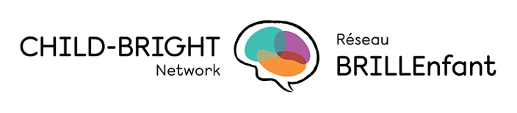

Paula Robeson, RN, BN, MScN, is the Senior Advisor, Knowledge Mobilization at Children’s Healthcare Canada, where she leads a modernized SPARK knowledge mobilization program. Paula is widely recognized for having pioneered the role of knowledge broker in the Canadian public health sector as a Knowledge Broker and Research Associate with Health Evidence at McMaster University. Paula subsequently developed and managed integrated knowledge mobilization teams, networks, and partnerships in several health service organizations across Canada, always with a view to promoting and facilitating evidence-informed decision making in a variety of health-related fields, including public health, child health, youth mental health, and substance use and addiction.

