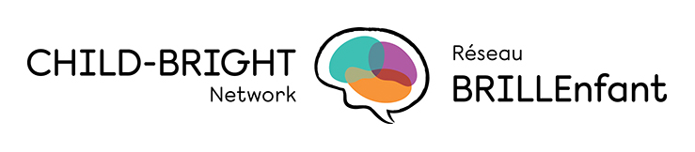

Aryeh Gitterman is currently an Adjunct Professor at Toronto Metropolitan University.

From 2007 to 2016 Aryeh was an Assistant Deputy Minister (ADM) in the Ontario Ministry of Children and Youth Services. While at MCYS, Aryeh was responsible for policies and programs for: autism, community-based mental health, child protection, special needs, residential services, and the poverty reduction strategy.

Prior to joining MCYS, Aryeh was ADM of the Instruction and Leadership Development Division, and the Business and Finance Division in the Ministry of Education. While at Education, he was responsible for policies and programs for: secondary schools, teacher quality, leadership development and safe schools.

Aryeh has presented at numerous meetings and conferences regarding education and children’s policies. Some examples: OECD, IMFAR (International Meeting for Autism Research), Asian Development Bank, American Educational Research Association, SickKids, World Bank, CAMH, Children’s Mental Health Ontario.

Aryeh began his career at the Scarborough Board of Education teaching high school Mathematics and English. He then worked at the Halton Board of Education, as a guidance counsellor, Head of Guidance and Special Education in a Grade 7-13 school, and as a Curriculum Coordinator for the school board.

Aryeh was born in Winnipeg where he received his B.Sc. at the University of Manitoba. He moved to Toronto where he completed his B.Ed., M.Ed. and his Doctor of Education in Counselling Psychology at the University of Toronto.

